Finger print based attendance system:

TEAM NAME: HSN9

TEAM MEMBERS: K.HARSHITHA.

N.SATHWIKA.

G.NAVYATEJA.

INTRODUCTION:

It is expected today that an individual who wants to authenticate himself for a service must have a token and/or password for example identity card, ATM card, driving license, health card and so on. Carrying different cards and remembering passwords for different services is a significant issue for individuals and organizations. A secure and effective identity management system plays an important role in the successful deployment of an attendance management system. To make the identity management system more secure and reliable for authentication, biometrics data are integrated in the attendance management systems . Biometrics technologies verify identity through characteristics such as fingerprints, faces, irises, retinal patterns, palm prints, voice, hand-written signatures, and so on. These techniques, which use physical data, are receiving attention as a personal authentication method that is more convenient than conventional methods such as a password or ID cards because it uses data taken from measurements and such data is unique to the individual and remains so throughout one’s lifetime . In these technologies, fingerprint becomes the most mature and popular biometrics technology used in automatic personal identification. The reason for the popularity of fingerprint verification is that fingerprints satisfy uniqueness, stability, permanency and easily taking [3]. In this paper, an attempt was made to look at the prevalence in the high level of impersonation experienced on a daily basis in both private and public sectors, the ghost worker syndrome which has become a menace across all tiers of government, employers concerns over the levels of absence in their workforce and difficulty in managing student attendance during lecture periods. Sequel to this, a fingerprint-based Attendance Management System was developed to provide a faster, more secure, and more convenient method of user verification than passwords and tokens can provide for a reliable personal identification of finger print.

ABSTRACT:

* Attendance systems are commonly used systems to mark the presence in offices and schools.
* From  manually marking the attendance in attendance registers to using high-tech applications and biometric systems, these systems have improved significantly.
* In this project, we used fingerprint Module and Arduino to take and keep attendance data and records.
* By using fingerprint sensor, the system will become more secure for the users.
* In this **fingerprint attendance system circuit**, we used **Fingerprint Sensor module** to authenticate a true person or employee by taking their finger input in the system.

HARDWARE COMPONENTS:

* R305 Finger print scanner
* Nodemcu ESP8266
* 16*2 OLED
* DS3231 RTC Module
* USB Cable connector
* LED
* Bread board
* Connecting wires

SOFTWARE COMPONENTS:

* Arduino IDE

R305 FINGER PRINT MODULE:

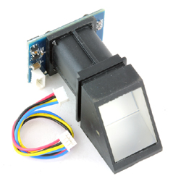

**Finger Print Sensor (R305) -TTL UART** is a finger print sensor module with TTL UART interface. The user can store the finger print data in the module and can configure it in 1:1 or 1: N mode for identifying the person. The finger print module can directly interface with 3v3 or 5v Microcontroller. A level converter (like MAX232) is required for interfacing with PC.

**Features of Finger Print Sensor (R305) -TTL UART:**

* Power DC : 3.6V-6.0V
* Interface : UART (TTL logical level)/ USB 1.1
* Working current : 100mA
* Peak Current    : 150mA
* Matching Mode:  1:1 and 1:N
* Baud rate (9600*N)bps, N=1-12 (default N=6 57600bps)
* Character file size:  256 bytes
* Image acquiring time :  <0.5s
* Template size :  512 bytes
* Storage capacity:  256
* Security level : 5 (1, 2, 3, 4, 5(highest))
* FAR : <0.001%
* FRR: <0.1%
* Average searching time:  < 0.8s (1:880)
* Window dimension : 18mm*22mm

NODEMCU ESP8266:

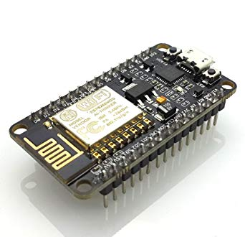

NodeMCU is an open source IoT platform. It includes firmware which runs on the ESP8266 Wi-Fi SoC from Espressif Systems, and hardware which is based on the ESP-12 module. The term "NodeMCU" by default refers to the firmware rather than the development kits. The firmware uses the Lua scripting language. It is based on the eLua project, and built on the Espressif Non-OS SDK for ESP8266. It uses many open source projects, such as lua-cjson and SPIFFS.

* Developer ESP8266: Open-source Community
* Type : Single-board microcontroller
* Introductory price : $5
* Operating system : XTOS
* CPU : ESP8266(LX106)
* Memory : 128kBytes
* Storage : 4MBytes
* Power : USB
* Since NodeMCU is open source platform, their hardware design is open for edit/modify/build.
* Node MCU Dev Kit/board consist of ESP8266 wifi enabled chip. The ESP8266 is a low-cost Wi-Fi chip developed by Espressif Systems with TCP/IP protocol.
* Node MCU Dev Kit has Arduino like Analog (i.e. A0) and Digital (D0-D8) pins on its board.
* It supports serial communication protocols i.e. UART, SPI, I2C etc.
* Using such serial protocols we can connect it with serial devices like I2C enabled LCD display, Magnetometer HMC5883, MPU-6050 Gyro meter + Accelerometer, RTC chips, GPS modules, touch screen displays, SD cards etc.

RTC MODULE:

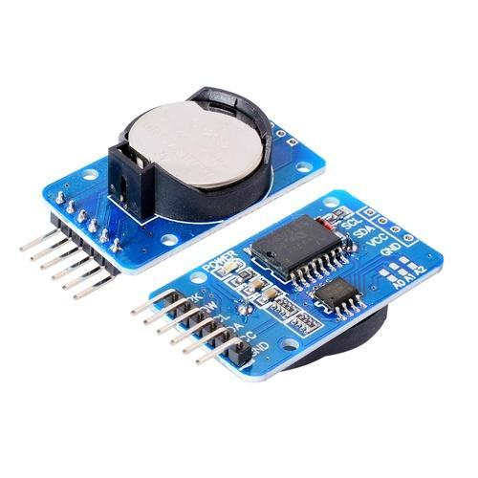

* Tiny RTC Module, for Arduino, contains a DS1307 real-time clock IC with a backup battery. It's one of the easiest to use RTCs out there, with Arduino and other libraries or simply use I2C commands to set and retreive the time and date. Includes a lithium coin cell battery which should be good for **four years** at least. It's very easy to use, and with our Arduino tutorial you'll be up and running in no time.  
     
   Along with the DS1307 real time clock, the module also has an Atmel 24C32 EEPROM chip which is handy for storing data without worrying about power loss. There is also space on the board to solder your own DS18B20 temperature sensor.

**Tiny RTC Module Specification:**

* Working voltage: 5V
* Two wire I2C interface
* Hour : Minutes : Seconds AM/PM
* Day Month, Date - Year
* Leap year compensation
* Accurate calendar up to year 2100
* Consumes Less than 500nA in Battery-Backup
* Battery included
* 1Hz output pin
* 56 Bytes of Non-volatile memory available to user
* 4KB of serial electrically erasable and programmable read only memory (EEPROM)
* Embed DS18B20 temperature sensor interface with the pull-up resistor
* Dimensions: 28mm x 25mm x 8mm

**Tiny RTC Module Package:**

* 1x Tiny RTC Module
* 1x Coin Cell Battery

OLED:

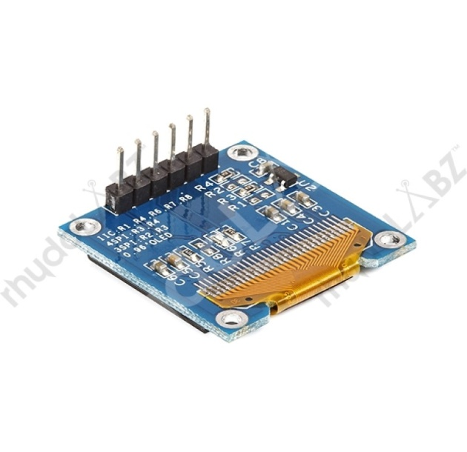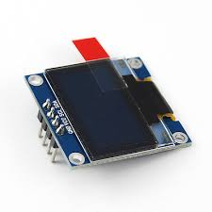

An organic light-emitting diode (OLED) is a light-emitting diode (LED) in which the emissive electroluminescent layer is a film of organic compound that emits light in response to an electric current. This organic layer is situated between two electrodes; typically, at least one of these electrodes is transparent. OLEDs are used to create digital displays in devices such as television screens, computer monitors, portable systems such as smartphones, handheld game consoles and PDAs. A major area of research is the development of white OLED devices for use in solid-state lighting applications.

Working principle:

A typical OLED is composed of a layer of organic materials situated between two electrodes, the anode and cathode, all deposited on a substrate. The organic molecules are electrically conductive as a result of delocalization of pi electrons caused by conjugation over part or all of the molecule. These materials have conductivity levels ranging from insulators to conductors, and are therefore considered organic semiconductors. The highest occupied and lowest unoccupied molecular orbitals (HOMO and LUMO) of organic semiconductors are analogous to the valence and conduction bands of inorganic semiconductors.

Advantages of OLED:

* Lower cost in the future.
* Lightweight and flexible plastic substrates
* Better picture quality
* Better power efficiency and thickness
* Response time

BLOCK DIAGRAM:

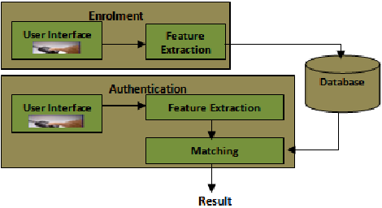

TABULAR COLUMN:

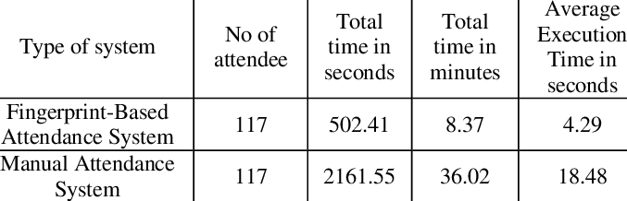

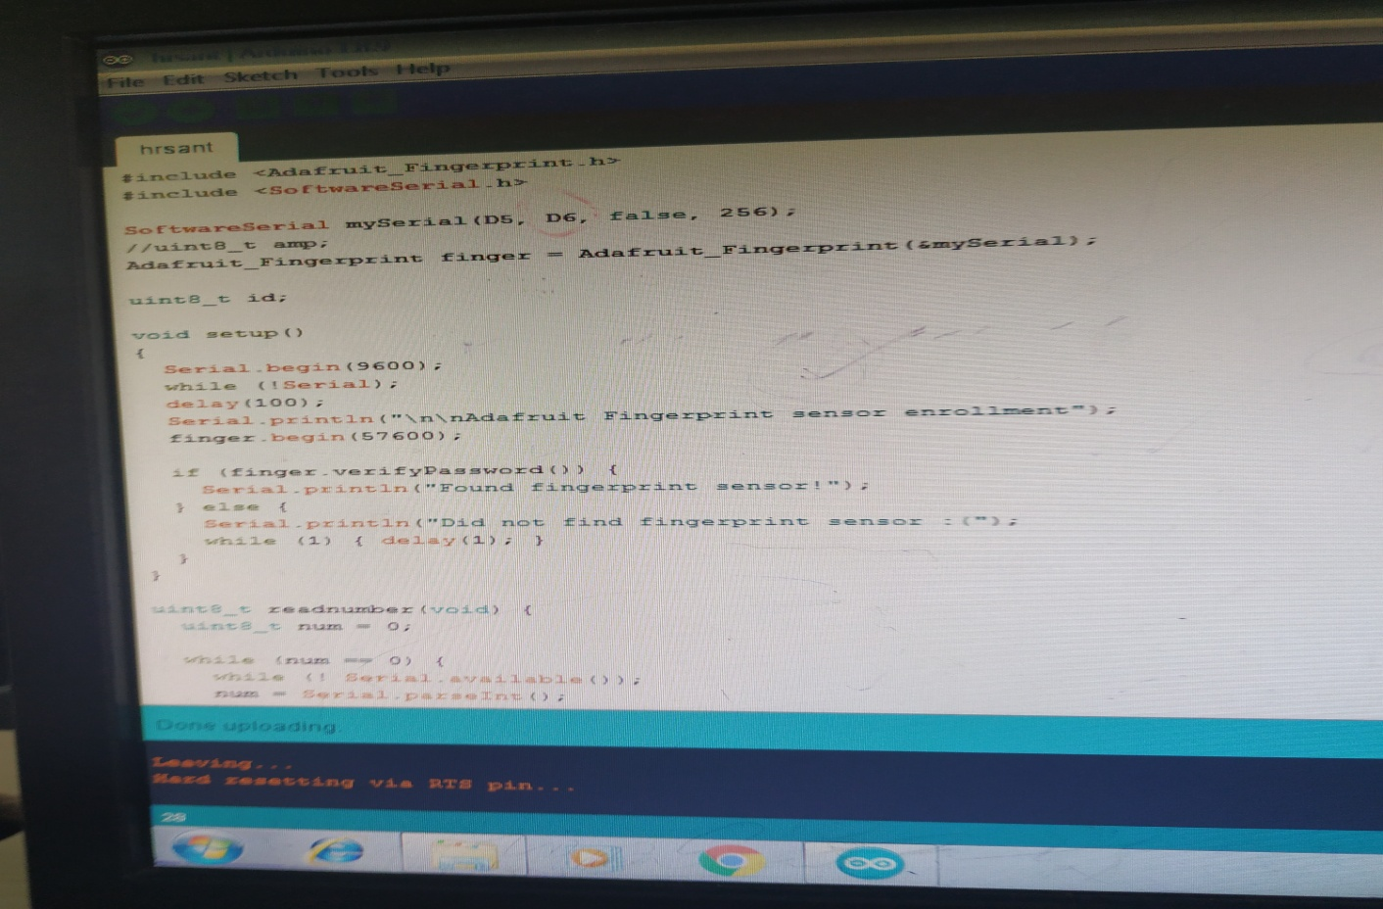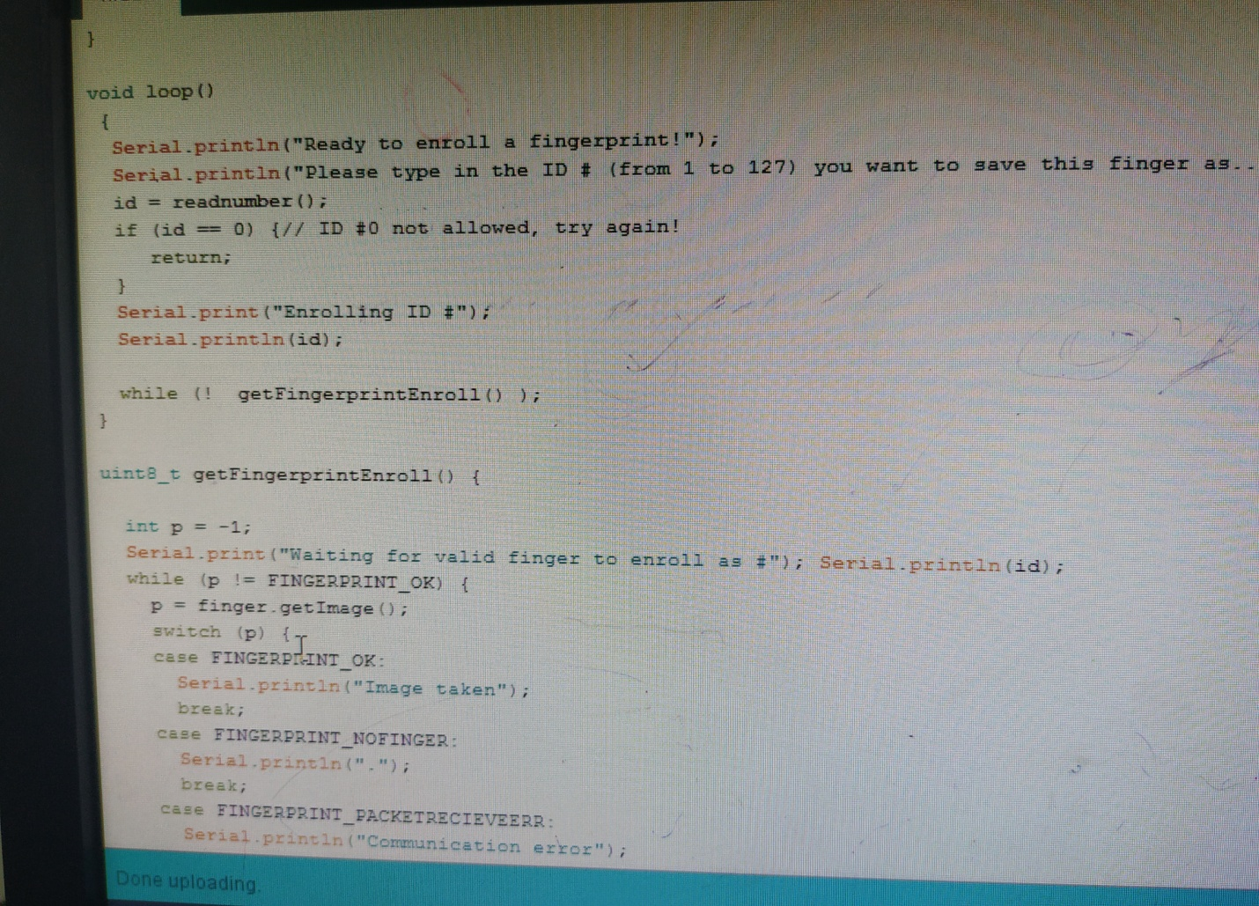

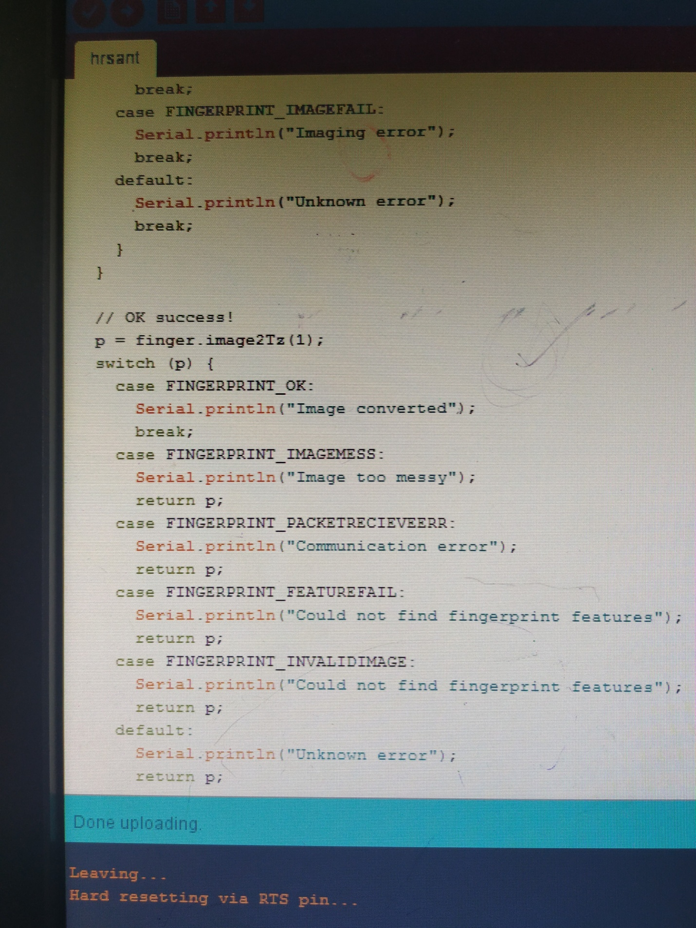

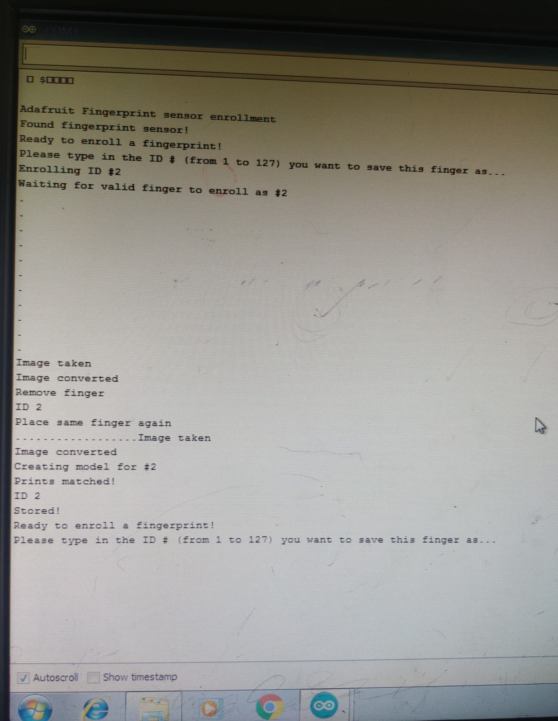

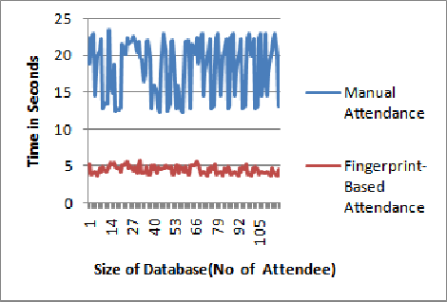

ADVANTAGES:

* It is used for security purpose.
* It is used for monitoring the person.
* There will be only one fingerprint for a person, it even differ for Twins.
* Speed accuracy is high i.e., responses in second.

DISADVANTAGES:

* **Using the fingerprint scanner does not take into consideration when a person physically changes.**
* **The cost of computer hardware and software programs can be expensive**
* **Using the fingerprint scanner can lead to false rejection and acceptance.**

CONCLUSION:

In this paper, we have presented a fingerprint-based attendance management system. The developed system is an embedded system that is part of a fingerprint recognition/authentication system based on minutiae points. The system extract the local characteristic of a fingerprint which is minutiae points in template based. Templates are matched during both registration and verification processes. For improved quality control during the registration or verification process, a matching score was used to determine the success of the operation. The matching score was specified so that only sets of minutiae data that exceed the score will be accepted and data below the score will be rejected. Therefore, Fingerprint Recognition using Minutia Score Matching method was used for matching the minutia points before attendance is recorded. The developed system is very helpful in saving valuable time of students and lecturers, paper and generating report at required time. The system can record the clock in and clock out time of students and workers in a very convenient manner using their fingerprint to prevent impersonation and reduce level of absence. Also, it reduces most of the administrative jobs and minimizes human errors, avoids proxy punching, eliminates time-related disputes and helps to update and maintain attendance records